**Simple E-Waste Reduction Strategies**

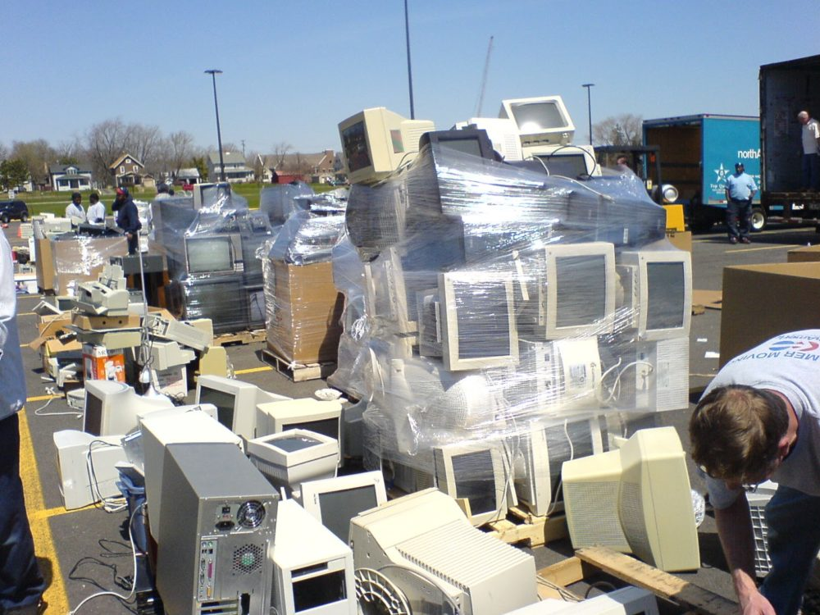

Technology has advanced so quickly in recent decades that it's difficult to picture a world without smartphones, GPS maps, laptops, and other electronic devices.

At the same time, the rapidly increasing volume of used electronics being wasted has raised severe concerns among environmental campaigners, state and local governments, and even the United Nations about how to reduce e-waste. There are currently more mobile phones on the planet than there are people, and the world's population is 7.5 billion. According to estimates from the Environmental Protection Agency, reusing the precious metals and polymers in old cell phones instead of mining for brand new materials can save enough energy to power up to 24,000 US households for a year.

The apparent solution has been recycling, which takes the pieces within devices that still have value and makes them available for new products, even if they are broken. However, e-waste recycling rates remain stubbornly low, which is why proponents of recycling are doing everything they can to raise awareness of the approach's long-term environmental and economic benefits.

There are actually quite basic methods that we can all help minimise e-waste, which is especially crucial at a time when our ever-increasing reliance on electronics has resulted in e-waste becoming the world's fastest-growing waste stream.

All it takes is your willingness to avoid either tossing away or keeping your used electronics in your closet or desk drawer.

In addition, e-waste reduction initiatives should involve an awareness of personal security, such as ensuring that any personal information on your electronic device is deleted so that it does not fall into the wrong hands.

**What are some suggestions for reducing e-waste?**

The challenge of minimising e-waste is one that everyone should be aware of and commit to, and it all starts with understanding why we don't want our old gadgets to end up in community landfills.

Electronic trash is described as abandoned electrical or electronic gadgets that, if disposed of in landfills, can cause human and environmental harm. These devices contain dangerous substances such as mercury and lead, and while they are safe to use, once they are disposed of, the poisons can leach into the soil and water, contaminating both. If those chemicals end up in your drinking water, you and your family are putting your health at risk.

And this isn't a little task. As technology advances and improves our devices, we are enticed to replace our older models with newer models, leading to a trend of just discarding these items. As a result, there is now a severe global e-waste problem.

It's not just about reducing environmental dangers when it comes to e-waste reduction. Minimizing e-waste conserves resources and minimises the amount of energy required to manufacture these products; recycling pieces inside e-waste consumes far less energy than manufacturing new ones.

We can also assist keep the cost of new consumer items down by making new products out of recycled parts. For manufacturers, this is a significantly less expensive option than mining for virgin ore to create new metals. This means that once manufacturers have access to the parts they need from the recycling industry, the cost of producing a new smartphone, or any other electronic gadget, decreases.

As a result, this is a win-win situation for everyone. Of course, the problem is that not enough people are aware that e-waste can be recycled.

As a result, helping to spread the information about recycling is one of the most powerful and effective ways to learn how to reduce e-waste.

If you recycle your e-waste, that's fantastic; you're already helping to reduce trash. Now it's time to take the next step and share your information with others – family, friends, neighbours, and coworkers — who may be unaware of the dangers posed by e-waste.

If you have a family member or friend who has recently purchased a new smartphone or laptop, or who simply wants to get rid of their old one, suggest that they recycle it with a reputable recycling company like Recycle Pro, which can make the parts within it available to new users and manufacturers.

It's also crucial to share your expertise about the negative consequences of discarding or retaining those devices; this offers individuals an incentive to follow your recommendations. Let your friends and relatives know how simple it is to recycle e-waste if they value recycling and faithfully toss their plastics, cans, and papers in municipal bins. They may easily contact a recycling company, such as Recycle Pro, and have their e-waste disposed of in the same manner.

**What Other Options Do You Have for Reducing E-Waste?**

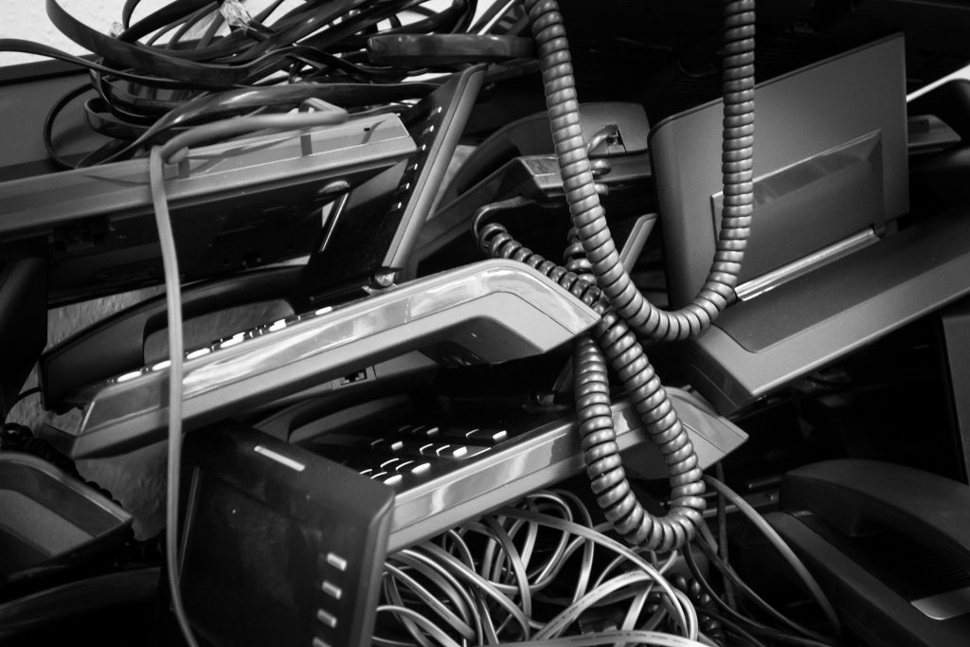

We all need to be prepared for the possible eruption of new devices — and the corresponding rush to discard older models — because our thirst for new technology is only expected to grow in the coming years.

There are various measures we may use to assist reduce the quantity of e-waste we generate. They are as follows:

1. Be a responsible consumer. When you are ready to purchase a new product, do your research. It should not break or be damaged very soon after it is purchased. Look for products that will last longer so you don't have to replace it every few months or years. This is a well-known practice in electronics. To make products last longer so that you can earn more money in the long term when they fail or malfunction, it's common.
2. Reuse as much as you can. You can repair any parts or equipment that is still in good condition before purchasing a new electronic device. If the device cannot be repaired any longer, you can recycle it.
3. Learn about what goes into your electronics. Knowledge is power. Researching the raw materials used in manufacturing your laptop or mobile phone will help you to understand the potential dangers of toxins and other harmful substances if they are thrown into a landfill. You can make informed purchases that aren't harmful to the environment.
4. You should look for labels that are environmentally friendly. Check to see if products are Energy Star-certified or certified by the Electronic Product Environmental Assessment Tool.
5. Limit the electronics you have. Look for multiple-function devices if you don't need them.
6. Teach children about e-waste. It is our future. We can help instill in children a commitment to e-waste recycling.
7. Recycle, recycle, recycle. It doesn't matter what kind of electronics you own, it is important to properly dispose of your electronic waste. This means that you should recycle all your old electronics.
8. Security issues are important. Even if you erase it, all of your personal data remains on your electronic devices. This is another reason to not throw it away. Recyle Pro, a recycling company, can clean your device before it is recycled so cyber thieves don't have access to that information.
9. Keep what you have. Making small changes can help you keep your computer working longer. To prolong the battery's life, clean your computer frequently and do not overcharge it.

Taking these steps and making those small changes, as well as encouraging others to do so, will significantly reduce e-waste.

**Conclusive Thoughts:**

Recycle Pro provides hardware Asset Management solutions to assist businesses in doing just that, reducing the expense of obsolete office gadgets.

They can also assist corporations in determining the worth of these products so that they can recoup some of their initial investment.

Individuals who have used or old technology that they no longer desire or utilise are in the same boat.

Large organisations, small to medium businesses, government agencies, schools, and non-profits can all benefit from Recycle Pro's comprehensive, single-source solutions. They may assist you with recycling in a Green Way manner.